**VV214 Final Project Proposal**

**Optimization of Traffic Flow in SJTU Minhang Campus**

Group 11: Liu Zeyuan, Shi Li, Yuan Fangqi

**I. Project background**

On national holidays, or when national examinations take place in main buildings like Dong Zhong Yuan or Dong Shang Yuan, continuous car flows may clog several cardinal roads of the campus, while other minor roads could be passed freely all day long. To eliminate this imbalance in the campus, and optimize the traffic situations, we raise this problem.

Meanwhile, traffic problem is always a major but tough problem in many big cities, including Shanghai. The model we build in this project can also be applied to a district or city, to help improve the traffic efficiency.

As a matter of fact, researchers have attempted to deal with this problem since long ago. The mainstream approaches include genetic algorithms, reinforcement learning, network flows, etc. Some researchers also collect real statistics from metropolises like Tokyo, New York, to fit their models. However, many of them pay attention to the control of traffic lights, which are lacking in our campus. Our focus could only be on adjusting road directions to reach a relative balance, consequently.

**II. Application of linear algebra in this project**

Linear algebra is useful in building our model. To understand the relationship between linear algebra and our simplified model of traffic flow in SJTU Minhang campus, we first introduce some key concepts.

A graph is a set of vertices and edges. Suppose crossroads and gates in the campus are vertices and roads are edges. Then we can simplify our campus as follows,

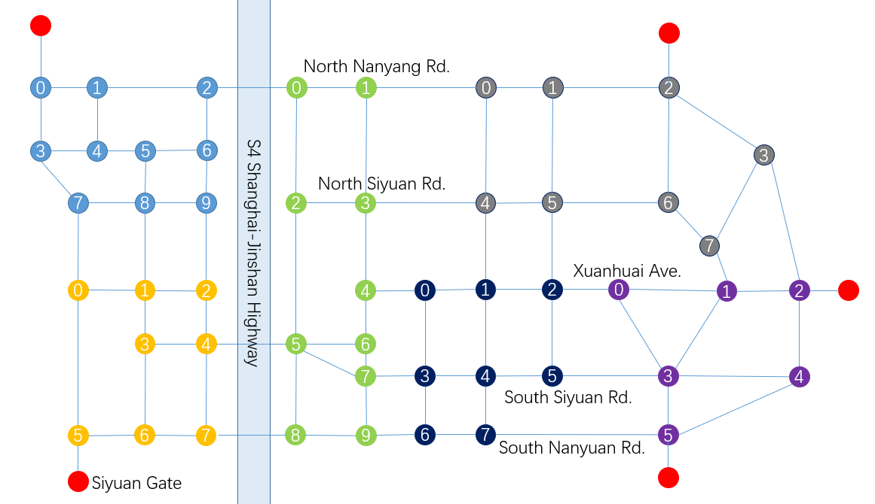

Fig 1. Simplified graph of SJTU Minhang campus

To describe this graph, we introduce the concept “adjacency matrix” $A$, and its element $a_{ij}$ is defined as follows,

$$a_{ij}=\left\{\begin{aligned}1, there exists an edge between vertex i and j \\ 0 , otherwise\end{aligned}\right.$$

To describe the real traffic condition more precisely, we can also modify the adjacency matrix. For example, we introduce “volume matrix” $V$, modified from adjacency matrix $A$, which each element describes the volume of the road between two vertices. Also, we may introduce directed edges to describe two-way traffic flow in a single road.

After construct the graph in detail, we are able to apply some algorithms in graph theory, such as Dijkstra algorithm, to describe a person who drive a car from one vertex to another. Based on the graph we have constructed and some useful algorithms, we can then try to optimize the traffic flow in each road.

**III. Sources**

Similar problems have been dealt with comprehensively in previous studies with graph theory. We would refer to one or two of them, and try to handle the problem under a more concrete background, as well as in a more simplified way. We would apply network-flow algorithms if necessary, so one or two papers concerning this algorithm might also be issued. Besides that, some basic theorems in graph theory are essential during this process, so a more theoretical source might be cited.

In summary, we would cite three to four sources throughout our study.

**IV. Graphs/Tables**

Our study concerns graph theory, and graphs are necessary consequently. We simplify the road map of SJTU campus to a net graph, and develop our theories on this basis. As for tables, the usage of tables is contingent. We will use them if necessary, such as to clarify the settings.

**V. Work Arrangements**

At present, we mainly communicate online and discuss our tasks. We would meet each other offline at least once a week in order to increase efficiency.

As for the division of the project, Liu Zeyuan takes the duty of modeling and calculations on paper. Shi Li is responsible for coding and programming, mainly using MATLAB. Yuan Fangqi will conceive articles summarizing all the results in order to complete the final poster.